**ETH MIKE – Manual v2.0**

Monika Zbytniewska

Rehabilitation Engineering Laboratory

ETH Zurich

BAA, Lengghalde 5

8092 Zurich

Switzerland

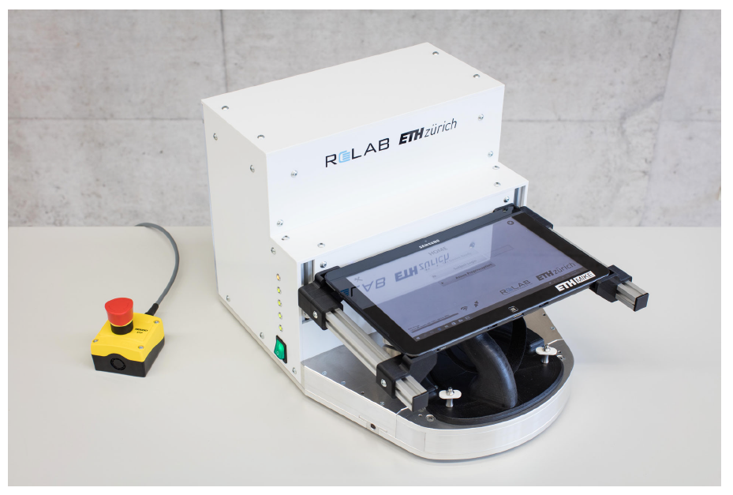

# Partlist

The robot ETH MIKE comes with the main parts shown in the figure and the table below.

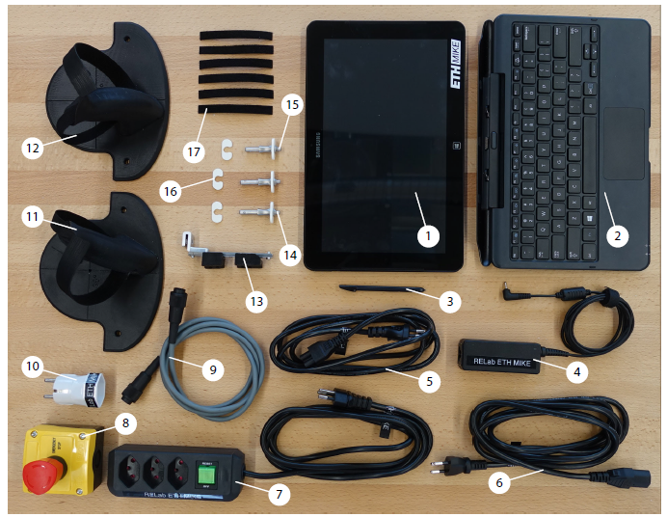

Figure 1: List of main components.

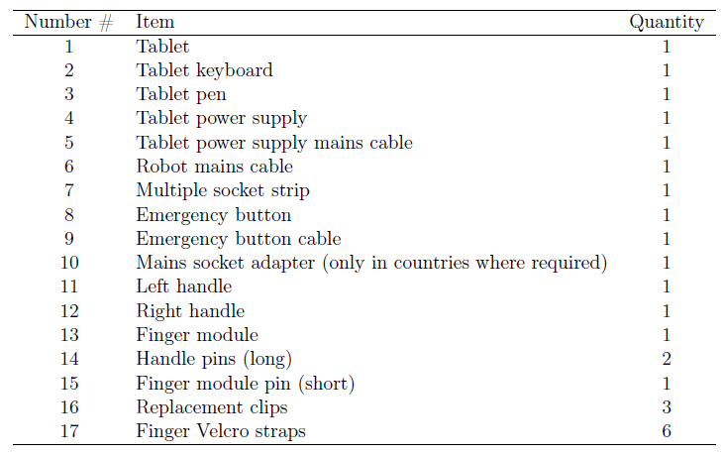

Table 1: List of main components.

Please note that in addition to the black handles in the picture there are also grey handles for children and a shorted figure module.

# Connections and basic functining

## 2.1 Cables

Ensure the robot is powered by connecting the robot mains cable #6 (Figure 2). The emergency button #8 must be connected to the robot with the emergency button cable #9. Otherwise, the actuation cannot be powered. Make sure that the tablet is powered from the mains during prolonged use.

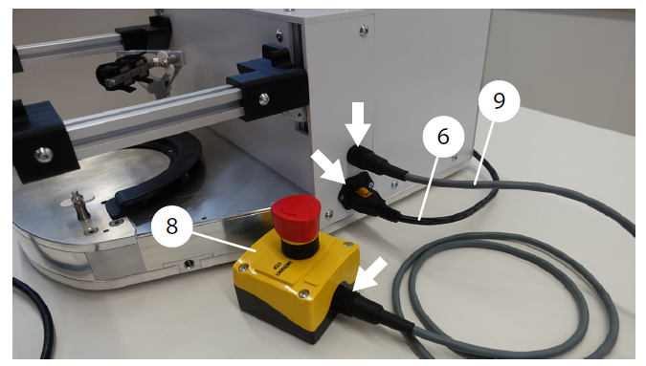

Figure 2: How to connect power cable and emergency button to the robot.

## Emergency button

The emergency button #8 has two states: released and pressed (see Figure 3). Pressing the emergency button cuts the current to the actuation of the robot and should only be used in emergencies. To re-enable the actuation, the emergency button needs to be released and the robot reset and calibrated from the software (see section 2.3).

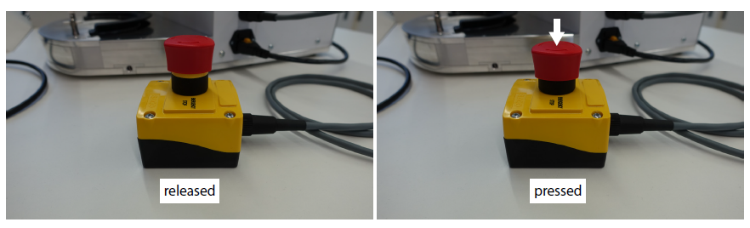

Figure 3: Emergency button – released and pressed.

## Robot calibration and LEDs

The robot needs to be calibrated every time you switch it on. As long as it is switched on, you don’t need to recalibrate it. Ensure the robot is switched on only when you are using it and that you don’t leave it switched on overnight.

In order to calibrate the robot, place the metal element in Figure 4A so that the holes covered the holes in the metal plate (you can also insert a screw as shown on the right side to stabilize it). Use the screw driver from the Allen key set as shown in figure 5. Alternatively, use the metal element in Figure 4B (insert it on one side; you don’t need to use a screw driver to insert it, simply rotate it) and push the end effector as close as possible to it.

This calibration process needs to be performed when you switch the device on. Wait a couple of seconds with the metal element inserted in the correct place until all LEDs are switched on and you hear a clicking sound. After this, you can remove the metal part and move the end-effector freely.

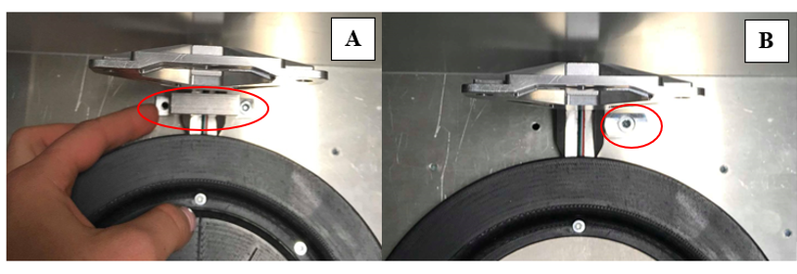

Figure 4: Calibration of the robot using a metal element to position the end-effector in the centre.

When the robot is switched off, all of the LEDs are off (Figure 5A). When you switch it on and the emergency button is released, 4 out of 5 LEDs will be turned on (Figure 5C). Then, after a few seconds (this is when the calibration element needs to be correctly inserted as in Figure 4), all LEDs will be switched on (Figure 5D). If the emergency button is pressed, not all LEDs will be turned on (Figure 5B). Ensure the emergency button is released and all LEDs are switched when using the robot for the experiments.

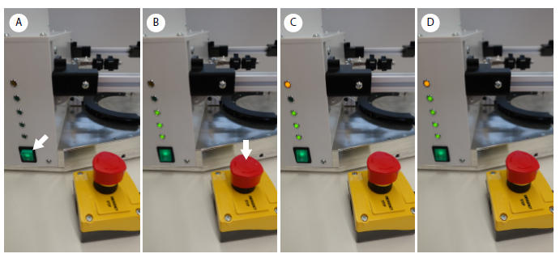

Figure 5: States of the LEDs on the side of the device.

# Software

## 3.l ETH MIKE Program

To start using the ETH MIKE robot software, first you need to switch on the tablet (button on the top). Then, log in to “Experimenter” window using the password “relab”.

Once you log in, you will see three folders in the middle of the screen, as shown in Figure 6.

The one on the left (“All_In_One 30 Deg ETH MIKE #1 32bit – English”) contains the gauge interface version for adults, while the one of the rights (“All_In_One 30 Deg ETH MIKE #1 32bit – English Children”) contains the gauge interface version for children (smaller in size). The one in the middle (“KSA Reliability Study”) is where the results of the position matching task are stored.

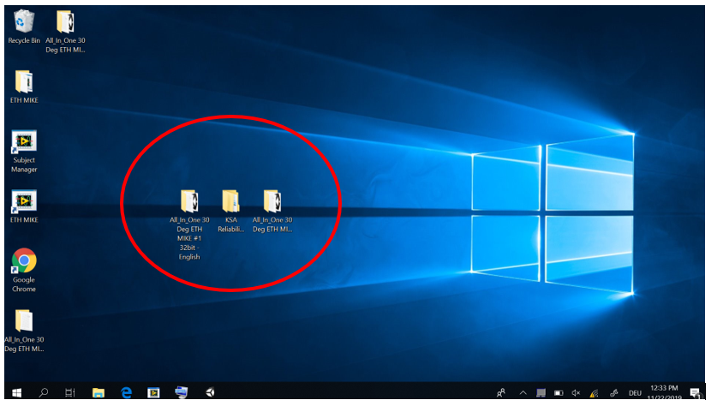

Figure 6: Main home menu of the tablet with the folders of interest.

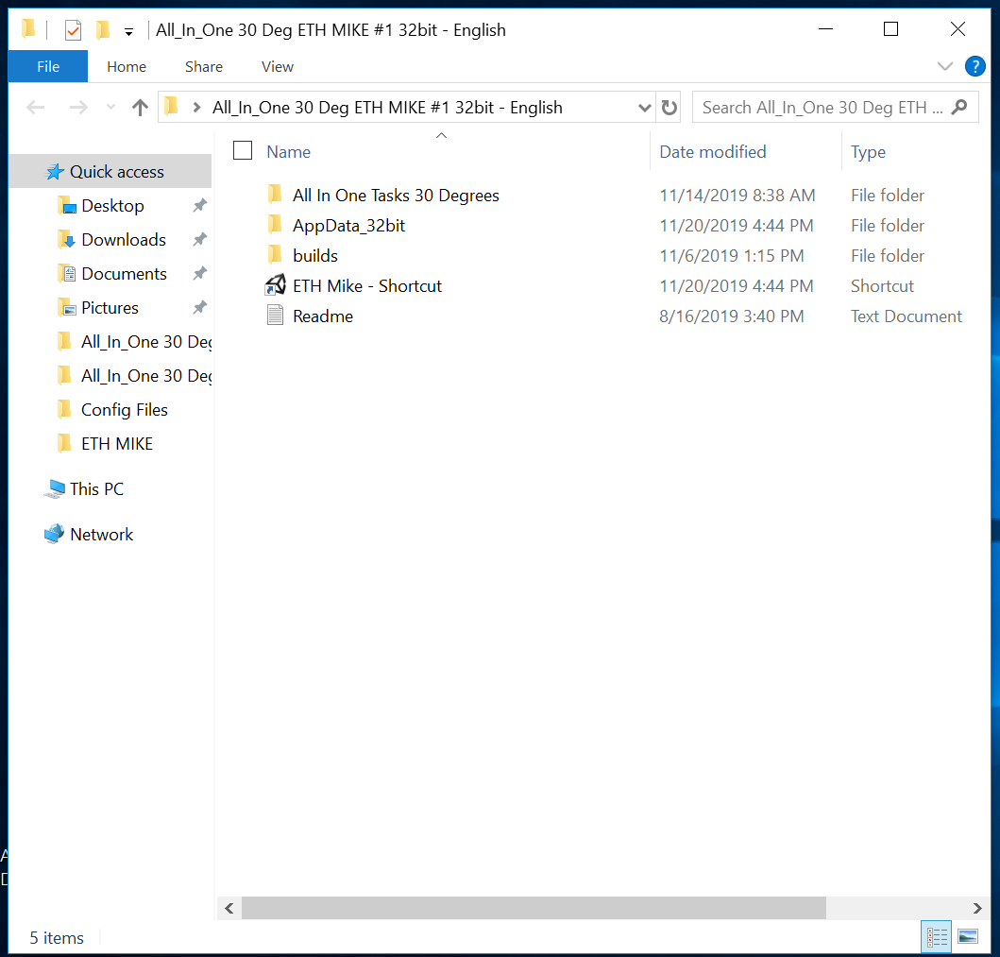

Figure 7: What is inside the folder with the ETH MIKE program. Click on the shortcut.

When you click on the folder on the left or on the right it will look inside like in Figure 7. Click on “ETH Mike – Shortcut” to start the program. The software will then start. Ensure that the button on the right side of the screen is green (it means that connection is established).

## Wifi connection with the robot

To ensure that ETH MIKE program is connected to the internal computer of the robot (and the button on the top of the screen is green), check if wifi connection with “myRIO_Mike” network is established (Figure 8).

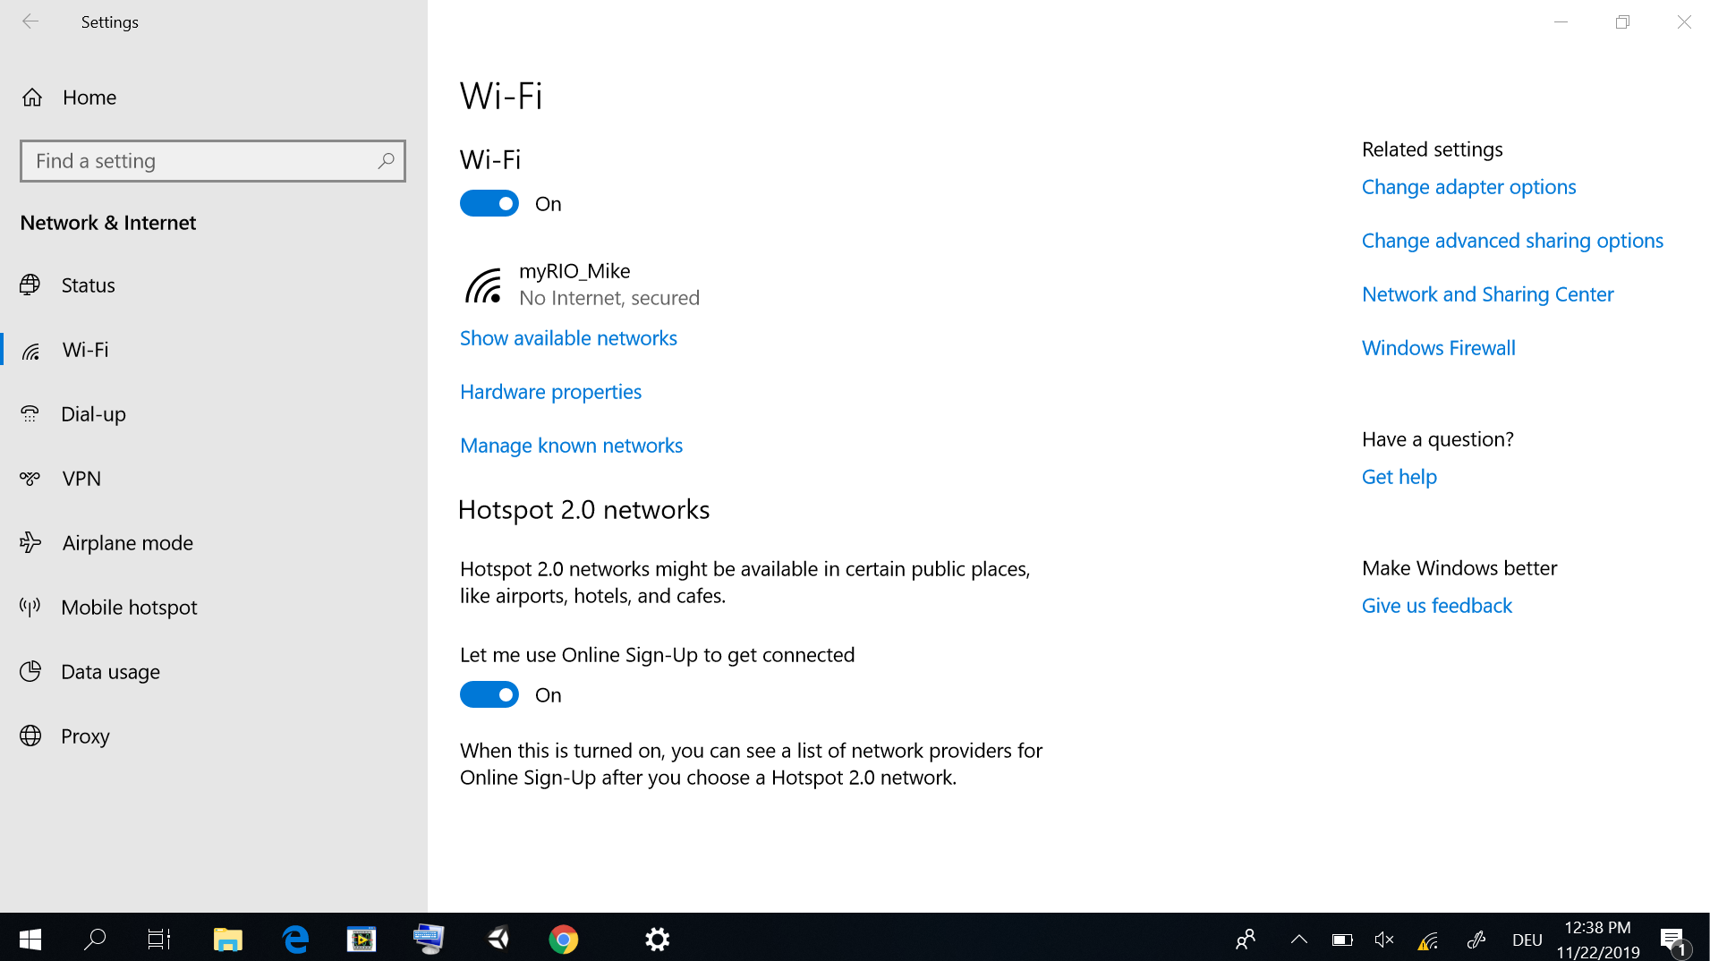

Figure 8: Wifi connection to “myRIO_Mike” ensures communication with ETH MIKE software.

# Assessments

Instructions for all assessments can be found when clicking on the question mark sign in the program.

# Data storage

The data is always stored under the subject number you create when logging into the ETH MIKE program. The data is stored differently for the position matching task (section 5.1) and for all other tasks (section 5.2).

## 5.1 Position matching task data storage

The data is stored in the folder located on the desktop “KSA Reliability Study”. Inside, you will find a folder corresponding to the subject number you input when logging into the ETH MIKE program (Figure 9). Once you click on the folder with that subject name, you will see “Position Matching Task” folder, inside it the folder “Left Hand” and “Right Hand” (if you have performed the experiment for both hands) and finally a text file (.txt) with a time stamp of when the file was created.

## 5.2 All other tasks

To download the data for all the other tasks (Force, Range of Motion, Target Reaching and Trajectory Following), go to Google Chrome and click on the favourites (Figure 10). This will lead you to a folder with subject numbers and then different task folders (Force, Range of Motion, Motor, Sensorimotor 🡪 note the name change! Target Reaching Task = Motor Task and Trajectory Following Task = Sensorimotor Task). Data for all tasks are stored in TDMS file and can then be opened in excel.

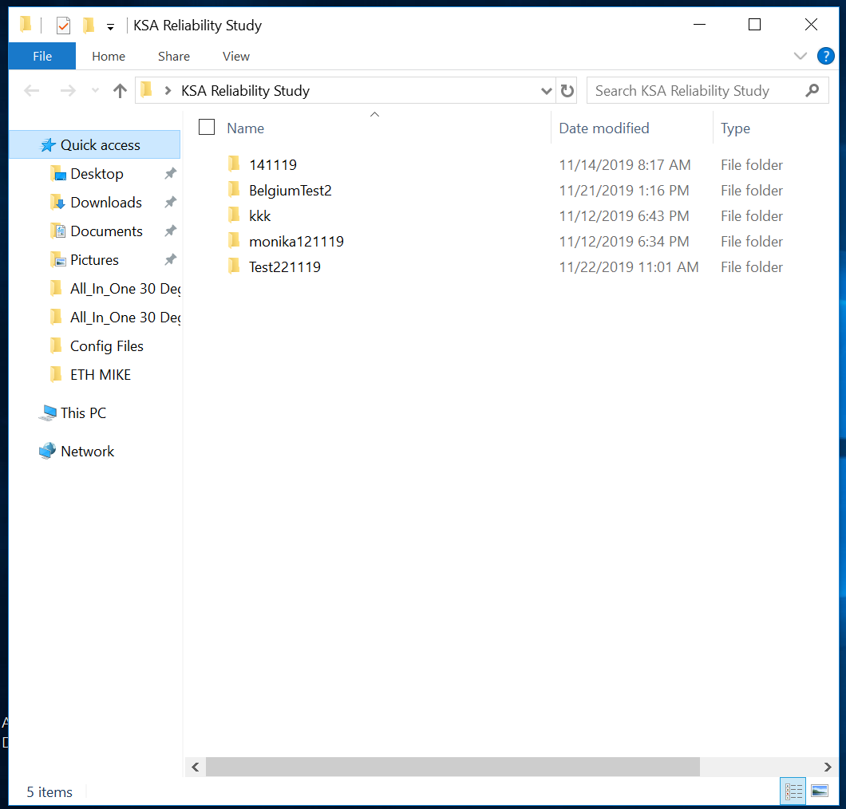

Figure 9: Folder containing Position Matching Task results in txt format.

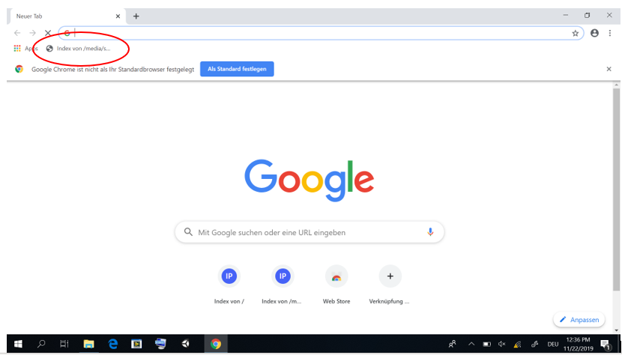

Figure 10: Google Chrome. Link to a folder containing all other task results in TDMS format.

# Packing for transportation

For transportation, the robot should be packed safely in its cardboard box (50x50x70 cm). First, bubble wrap should be put around the rectangular part of the robot with the electronics inside. Then the robot should be placed on the polystyrene block glued to a cardboard bottom layer #P1 (Figure 11, 1). Together it should be slided into the box. Then the polystyrene block #P2 should be placed on the robot, where the tablet goes during use. To avoid damaging the force sensor of the robot, care must be taken to centre the moving part of the robot, so it fits into the slit in the polystyrene (Figure 11, 1, red arrow). All the parts displayed in Figure 1 should be stored in re-sealable zipper storage bags, wrapped in bubble wrap and stored above #P2. Additionally, the polystyrene block #P3 should be added for stability (Figure 11, 2). Next, #P4 can be added, and the tablet (together with its keyboard) can be stored in it (Figure 11, 3). As final protections, the last layer of polystyrene #P5 and a double cardboard layer #P6 should be added (Figure 11, 4 and 5), before closing and sealing the cardboard box. Any severe shocks and vibrations should be avoided. The robot weights about 17 kg.

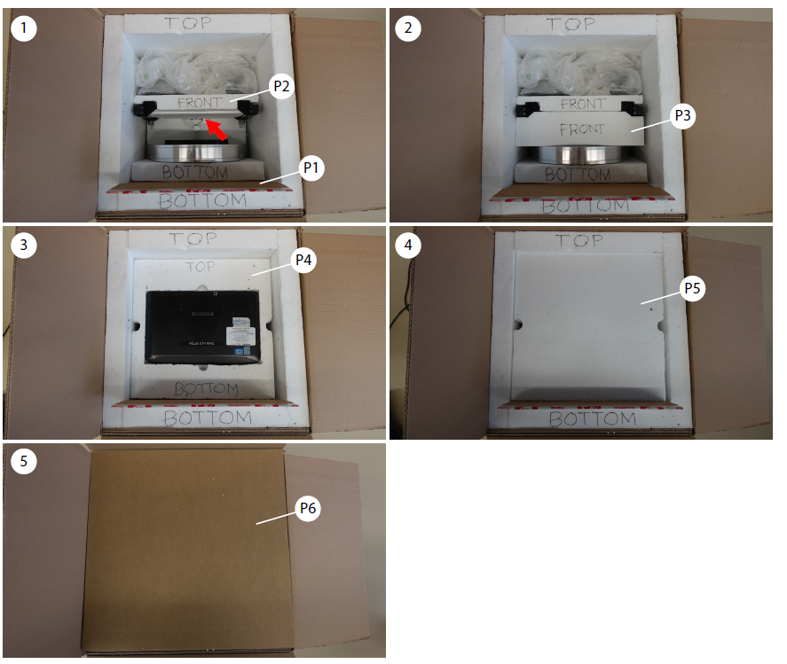

Figure 11: How to pack the robot safely.

# Contact information

Rehabilitation Engineering Laboratory

Monika Zbytniewska

ETH Zurich

BAA, Lengghalde 5

8092 Zurich

+41 747 863 6755

mike.rinderknecht@hest.ethz.ch

<http://www.relab.ethz.ch>

Rehabilitation Engineering Laboratory

Olivier Lambercy

ETH Zurich

BAA, Lengghalde 5

8092 Zurich

+41 44 510 7246

olivier.lambercy@hest.ethz.ch

<http://www.relab.ethz.ch>